**NUTRITION ASSISTANT APPLICATION**

|  |  |  |  |  |
| --- | --- | --- | --- | --- |
| **S.NO** | **REG.NO** | **NAME** | **DEPARTMENT** | **TEAM** |
| 1. | 730919104111 | SRI BHARATHI | CSE | Team Leader |
| 2. | 730919104067 | NALAJALA SAIBHARGAV | CSE | Team Member 1 |
| 3. | 730919104101 | SARATHI NIWAS | CSE | Team Member 2 |
| 4. | 730919104131 | VINOTH KUMAR | CSE | Team Member 3 |

**DONE BY**

**TEAM ID: PNT2022TMID09772**

1. **INTRODUCTION**

A primary goal of the project is to provide you with information backed by nutritional science, and a variety of resources that use scientific evidence to optimize health and prevent disease. This text was designed to support, enrich, and expand the materials provided. The objective of this study is to identify dietary self-monitoring implementation strategies on a mobile application. Nutritional knowledge is essential for promoting good eating habits since it ensures that necessary nutrient requirements are met to avoid malnutrition.

1. **PROJECT OVERVIEW**

This project aims at building a web App that automatically estimates food attributes such as ingredients and nutritional value by classifying the input image of food. Our method employs **Clarifai's AI- Driven Food Detection Model** for accurate food identification and Food API's to give the nutritional value of the identified food.

1. **PURPOSE**

One of the most basic functions is to guide its users towards a healthy diet and assist them to achieve their health goals. So, once your user specifies the goal like desired weight goal, body type, food habits, and preferred food items, your app must suggest them with a proper diet accordingly. You can automatically calculate the nutritional information for any recipe, analyze recipe costs, visualize ingredient lists, find recipes for what's in your fridge, find recipes based on special diets, nutritional requirements, or favorite ingredients, classify recipes into types and cuisines, convert ingredient amounts, or even compute an entire meal plan.

1. **IDEATION PHASE**
   1. EMPATHY MAP

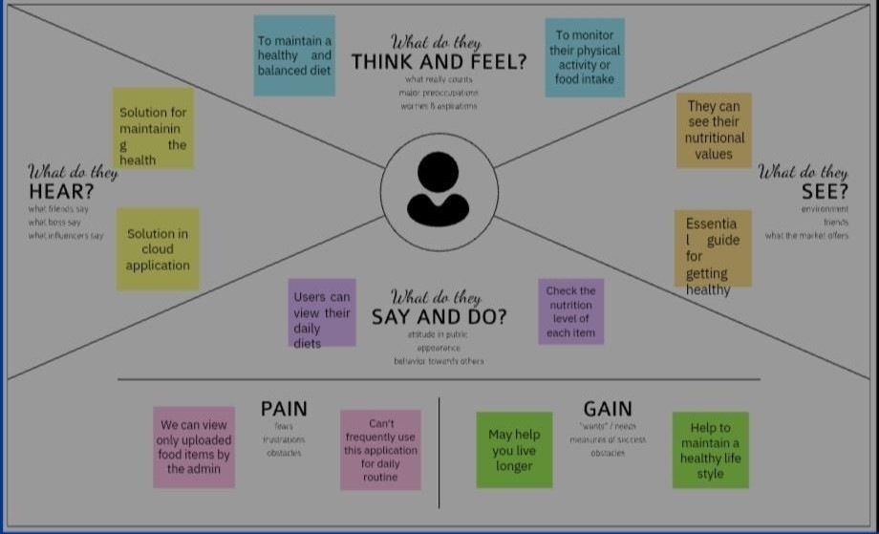

* 1. BRAINSTORMING

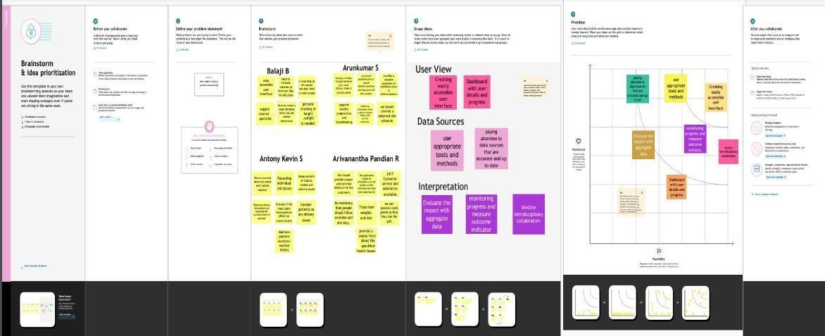

* 1. LITERATURE SURVEY

DOMAIN: CLOUD ASSISTANT DEVELOPMENT

TOPIC : NUTRITION ASSISTANT APPLICATION

1. Rationale and developmental methodology for the simple approach: A Systematised, Interdisciplinary Malnutrition Pathway for implementation and Evaluation in hospitals

AUTHOR : Jack J Bell 1 2, Adrienne Young 3 4, Jan Hill 5,

Merrilyn Banks 3 4, Tracy Comans 6, Rhiannon Barnes 7,

Heather H Keller 8 9 ABSTRACT :

Changing population demographics, service demands, and healthcare provider expectations suggest that a shift is required regarding how malnutrition care is managed in hospitals. The present study aims to build the reason for required change, and to describe the process used to develop a model for managing malnutrition for implementation across six Queensland hospitals. A cross-sectional survey of approaches to managing malnutrition in Queensland public hospitals, and development of a new model of care (guided by Knowledge-to-Action Framework and qualitative interviews) for testing within a broader implementation program.Twenty-three surveys were distributed with 21 completed by metropolitan (n = 11), regional (n = 8), and rural/remote (n = 2) settings. Substantial within and across site variance was observed, with care processes focused towards highly individualized, dietitian delivered care. Some early adopter sites demonstrated systematic, interdisciplinary or delegated malnutrition care processes; however, the latter was rarely or never undertaken in eight sites. A model for the Systematised,

Interdisciplinary Malnutrition Pathway for impLementation and Evaluation (SIMPLE) in hospitals was drafted based on identified contemporary models and supporting literature. A mixed-methods approach combined survey data with structured interviews conducted in six sites, purposely sampled for maximal variation to iteratively refine the model. Consensus for implementation of the final model was achieved across site clinicians, leaders, and governance structures. Systematised, delegated, and interdisciplinary nutrition care activities are realistic in at least some settings. A model is now available to provide interdisciplinary care. Next steps including testing implementation will determine if this interdisciplinary model improves malnutrition care delivered in hospitals.

REFERLINK

:https://pubmed.ncbi.nlm.nih.gov/29436107/

1. Orthogeriatric care for the elderly with hip fractures: where are we? AUTHOR : Giulio Pioli 1, Andrea Giusti, Antonella Barone

ABSTRACT :

Hip fracture (HF) is a major health care problem in the Western world, associated with significant morbidity, mortality and loss of function. Its incidence is expected to increase as the population ages. The authors discuss the role of a coordinated multidisciplinary team in the management of patients during hospital stay, at discharge and during rehabilitation. Orthogeriatric care should not just be viewed as a multidisciplinary activity, but as a radical alternative to the traditional model of care, an alternative based on all those strategies in which evidence shows an improvement in outcomes in the fractured elderly. Therefore, key points of the care are early surgery, immediate mobilization, prevention and management of delirium, pain and malnutrition, as well as an integrated and multidisciplinary approach. Comprehensive geriatric assessment is useful in identifying frail elderly and in providing information that is essential in formulating clinical recommendations and making care plans. In each hospital, the orthogeriatric unit should represent a center of excellence for treating elderly patients with major fractures. However, when an orthogeriatric project is implemented, it is essential that detailed data about the casemix of patients, process of care and outcomes are collected, to compare the results with historical data and to be able to participate in audit processes

REFERLINK [:https://pubmed.ncbi.nlm.nih.gov/18431078/](https://pubmed.ncbi.nlm.nih.gov/18431078/)

1. Recognizing malnutrition in adults: definitions and characteristics, screening, assessment, and team approach

AUTHOR : Gordon L Jensen 1, Charlene Compher, Dennis H Sullivan, Gerard E Mullin

ABSTRACT :

Appropriate recognition of malnutrition in adults requires knowledge of screening and assessment methodologies. An appreciation for the contributions of inflammation has resulted in a new etiology-based approach to defining malnutrition syndromes. The Academy of Nutrition and Dietetics and the American Society for Parenteral and Enteral Nutrition (A.S.P.E.N.) have published a consensus document that extends this approach to describe characteristics for the identification and documentation of malnutrition in adults. Nutrition screening tools are used to identify patients at nutrition risk and those who are likely to benefit from further assessment and intervention. Nutrition assessment serves to guide appropriate intervention. A systematic approach to nutrition assessment that supports the new diagnostic scheme and criteria from the Academy and A.S.P.E.N. has recently been presented. Since screening delays and failures in the diagnosis and management of malnutrition are all too common, a multidisciplinary team approach is recommended to promote improved communication

REFERLINK : <https://pubmed.ncbi.nlm.nih.gov/23969411/>

1. Update on the Integrated Nutrition Pathway for Acute Care (INPAC):

post implementation tailoring and toolkit to support practice improvements

AUTHOR : Heather Keller, Celia Laur, Marlis Atkins, Paule Bernier, Donna Butterworth, Bridget Davidson, Brenda Hotson,

Roseann Nasser, Manon Laporte, Chelsa Marcell, Sumantra Ray & Jack

Bell ABSTRACT :

The Integrated Nutrition Pathway for Acute Care (INPAC) is an evidence and consensus based pathway developed to guide health care professionals in the prevention, detection, and treatment of malnutrition in medical and surgical patients. From 2015 to 2017, the More-2-Eat implementation project (M2E) used a participatory action research approach to determine the feasibility, and evaluate the implementation of INPAC in 5 hospital units across Canada. Based on the findings of M2E and consensus with M2E stakeholders, updates have been made to INPAC to enhance feasibility in Canadian hospitals. The learnings from M2E have been converted into an online toolkit that outlines how to implement the key steps within INPAC. The aim of this short report is to highlight the updated version of INPAC, and introduce the implementation toolkit that was used to support practice improvements towards this standard.

REFERLINK : [https://nutritionj.biomedcentral.com/articles/10.1186/s129370170310-1](https://nutritionj.biomedcentral.com/articles/10.1186/s12937-017-0310-1) 5.Multidisciplinary, multi-modal nutritional care in acute hip fracture inpatients - results of a pragmatic

intervention

AUTHOR : Jack J Bell 1, Judith D Bauer 2, Sandra Capra 3, Ranjeev Chrys Pulle 4

ABSTRACT :

Malnutrition is highly prevalent and resistant to intervention following hip fracture. This study investigated the impact of individualized versus multidisciplinary nutritional care on nutrition intake and outcomes in patients admitted to a metropolitan hospital acute hip fracture unit. A prospective, controlled before and after comparative interventional study aligning to the CONSORT guidelines for pragmatic clinical trials. Randomly selected patients receiving individualized nutritional care (baseline) were compared with post interventional patients receiving a new model of nutritional care promoting nutrition as a medicine, multidisciplinary nutritional care, foodservice enhancements, and improved nutrition knowledge and awareness. Malnutrition was diagnosed using the Academy of Nutrition and Dietetics criteria. Fifty-eight weighed food records were available for each group across a total of 82 patients (n = 44, n = 38). Group demographics were not significantly different with predominantly community dwelling (72%), elderly (82.2 years), female (70%), malnourished (51.0%) patients prone to co-morbidities (median 5) receiving early surgical intervention (median D1). Multidisciplinary nutritional care reduced intake barriers and increased total 24-h energy (6224 vs. 2957 kJ; p < 0.001) and protein (69.0 vs. 33.8 g; p < 0.001) intakes, reduced nutritional deterioration over admission (5.4 vs.

20.5%; p = 0.049), and increased discharge directly back to the community setting (48.0 vs. 17.6%; p = 0.012). Trends suggested a reduction in median length of stay (D13 vs. D14). Inpatient mortality remained low across groups (5.2%, 2.3%). Multidisciplinary nutritional care improves nutrition intake and outcomes in acute hip fracture inpatients. Similar pragmatic study designs should be considered in other elderly inpatient populations perceived resistant to nutritional intervention.

REFERLINK :<https://pubmed.ncbi.nlm.nih.gov/24388594/>

1. Lost in knowledge translation: time for a map?

AUTHOR : Ian D Graham 1, Jo Logan, Margaret B Harrison,

Sharon E Straus, Jacqueline Tetroe, Wenda Caswell, Nicole Robinson ABSTRACT :

There is confusion and misunderstanding about the concepts of knowledge translation, knowledge transfer, knowledge exchange, research utilization, implementation, diffusion, and dissemination. We review the terms and definitions used to describe the concept of moving knowledge into action. We also offer a conceptual framework for thinking about the process and integrate the roles of knowledge creation and knowledge application. The implications of knowledge translation for continuing education in the health professions include the need to base continuing education on the best available knowledge, the use of educational and other transfer strategies that are known to be effective, and the value of learning about planned action theories to be better able to understand and influence change in practice settings. REFERLINK :

<https://pubmed.ncbi.nlm.nih.gov/16557505/>

1. Changing nutrition care practices in hospital: a thematic analysis of hospital staff perspectives AUTHOR : Celia Laur 1, Renata Valaitis 1, Jack Bell 2, Heather Keller 3 4 ABSTRACT :

Many patients are admitted to hospital and are already malnourished. Gaps in practice have identified

that care processes for these patients can be improved. Hospital staff, including management, needs to work towards optimizing nutrition care in hospitals to improve the prevention, detection and treatment of malnutrition. The objective of this study was to understand how staff members perceived and described the necessary ingredients to support change efforts required to improve nutrition care in their hospital. A qualitative study was conducted using purposive sampling techniques to recruit participants for focus groups (FG) (n = 11) and key informant interviews (n = 40) with a variety of hospital staff and management. Discussions based on a semistructured schedule were conducted at five diverse hospitals from four provinces in Canada as part of the More-2-Eat implementation project. One researcher conducted 2-day site visits over a two-month period to complete all interviews and FGs. Interviews were transcribed verbatim while key points and quotes were taken from FGs. Transcripts were coded line-by-line with initial thematic analysis completed by the primary author. Other authors (n = 3) confirmed the themes by reviewing a subset of transcripts and the draft themes. Themes were then refined and further detailed. Member checking of site summaries was completed with site champions. Participants (n = 133) included nurses, physicians, food service workers, dietitians, and hospital management, among others. Discussion regarding ways to improve nutrition care in each specific site facilitated the thought process during FG and interviews. Five main themes were identified: building a reason to change; involving relevant people in the change process; embedding change into current practice; accounting for climate; and building strong relationships within the hospital team. Hospital staff need a reason to change their nutrition care practices and a significant change driver is perceived and experienced benefit to the patient. Participants described key ingredients to support successful change and specifically engaging the interdisciplinary team to effect sustainable improvements in nutrition care.

REFERLINK : <https://pubmed.ncbi.nlm.nih.gov/28724373/>

4.4 PROBLEM STATEMENTS

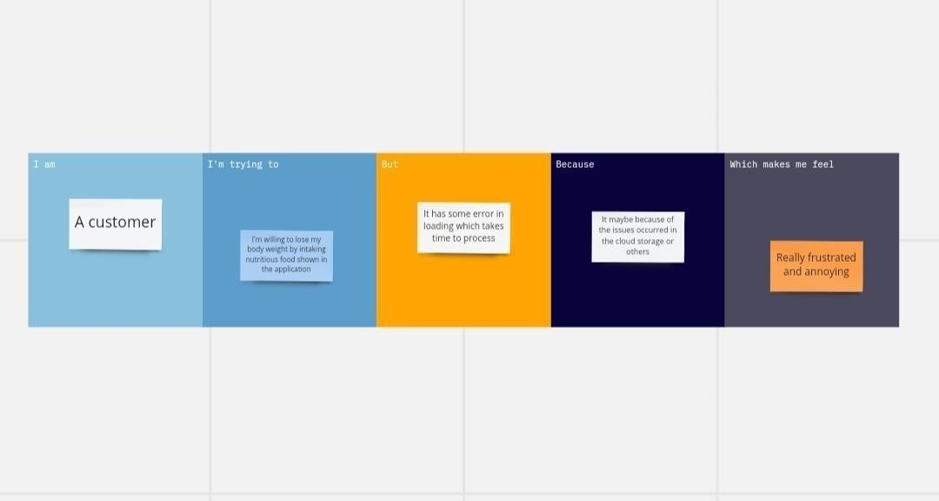

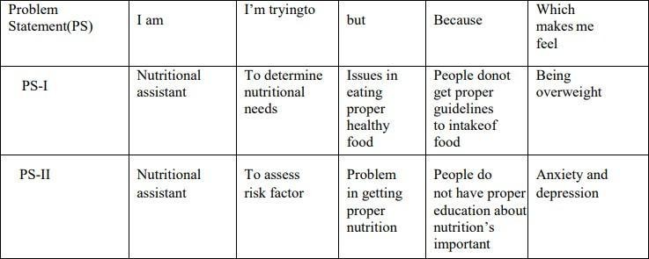

* 1. REQUIREMNT ANALYSIS
     1. FUNCTIONAL REQUIREMENTS
        + User Registration
        + User Confirmation
        + Update Profile
        + User Authentication
        + Report
     2. NON FUNCTIONAL REQUIREMENTS

Usability Security

Reliability Performance Availability Scalability

* 1. PROJECT DESIGNS
     1. PROBLEM SOLUTION FIT

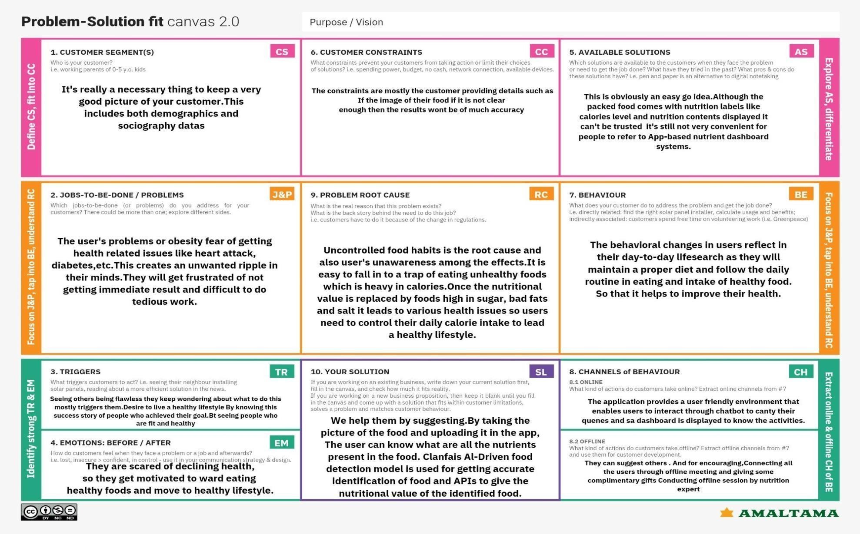

* + 1. PROPOSED SOLUTION

The project aims at developing an application that helps people to lead a healthy lifestyle by providing information about the ingredients and their nutritional content in the food they are consuming. By this people can avoid various health-related issues like obesity, heart attack, diabetics etc. Monitoring and tracking of goal and diet plans will be provided for the user based on the data collected from them.Project team shall fill the following information in proposed solution template.

|  |  |  |
| --- | --- | --- |
| **S.No.** | **Parameter** | **Description** |
| 1. | Problem Statement (Problem to be solved) | Poor eating habits include under- or overeating, not having enough of the healthy foods we need each day.Poor nutrition can impair our daily health and wellbeing and reduce our ability to lead an enjoyable and active life.However, although food packaging comes with nutrition (and calorie) labels, it’s still not very convenient for people on comparing to App based nutrient dashboard systems which can analyze real-time images of a meal and analyze it for mitional content which can be very handy and improves the dietary habits, and therefore helps in maintaining a healthy lifestyle |
| 2. | Idea / Solution description | Choosing healthier foods (whole grains, fruits and vegetables, healthy fats and protein sources) and beverages. Limiting unhealthy foods (refined grains and sweets, potatoes, red meat, processed meat) and beverages (sugary drinks) Increasing physical activity. Limiting television time, screen time.  IDEA :  Make available all kinds of food for different users like some of the users are heart patients, affected by any health issues.and includes learning to automatically identify & quantify thousands of food categories and pair the food items with the relevant nutritional information for individuals to monitor and maintain the level of calorie intake. |
| 3. | Novelty / Uniqueness | People are interested in calculating amounts of sugar and fat they consume. You need to create a diet and nutrition app with a sugar and fat tracker. This tracker may go in connection with automatically generated recommendations that fit individual cases. |

|  |  |  |
| --- | --- | --- |
| 4. | Social Impact / Customer Satisfaction | Teenagers get more benefits since they worry more about their looks to be flawless. This also makes them live longer.Parents benefit since they no need to worry about their kids being unhealthy from an earlier age. |
| 5. | Business Model (Revenue Model) | Nutrition assistant application Website |
| 6. | Scalability of the Solution | Healthy nutrition contributes to preventing diseases. Knowledge about the effects of the long term provision of health-aware recommendations in real-life situations is made possible. |

* + 1. SOLUTION ARCHITECTURE

Due to the ignorance of healthy food habits, obesity rates are increasing at an alarming speed, and this is reflective of the risks to people’s health. People need to control their daily calorie intake by eating healthier foods, which is the most basic method to avoid obesity. However, although food packaging comes with nutrition (and calorie) labels, it’s still not very convenient for people to refer to App-based nutrient dashboard systems which can analyze real-time images of a meal and analyze it for nutritional content which can be very handy and improves the dietary habits, and therefore, helps in maintaining a healthy lifestyle.

**SOLUTION ARCHITECTURE DIAGRAM**

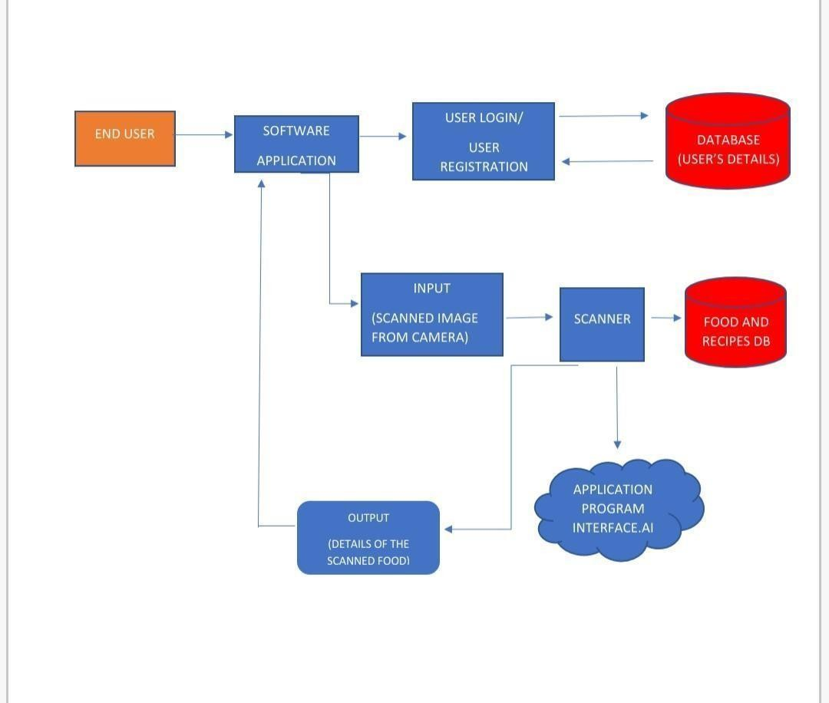

* + 1. CUSTOMER JOURNEY

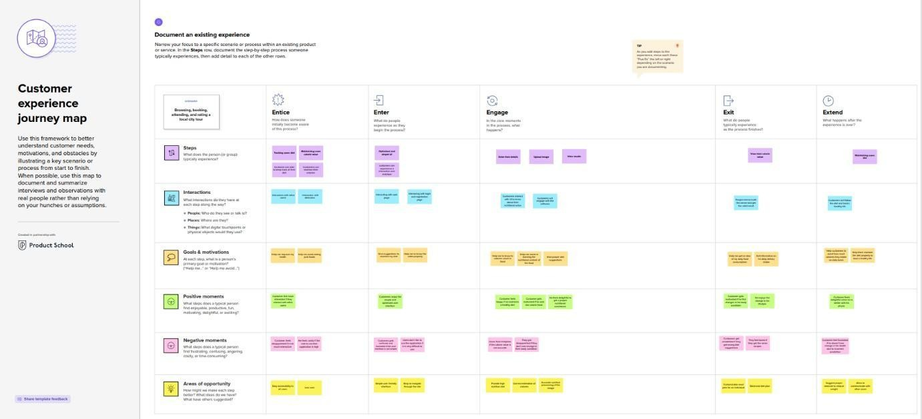

* + 1. DATA FLOW DIAGRAM

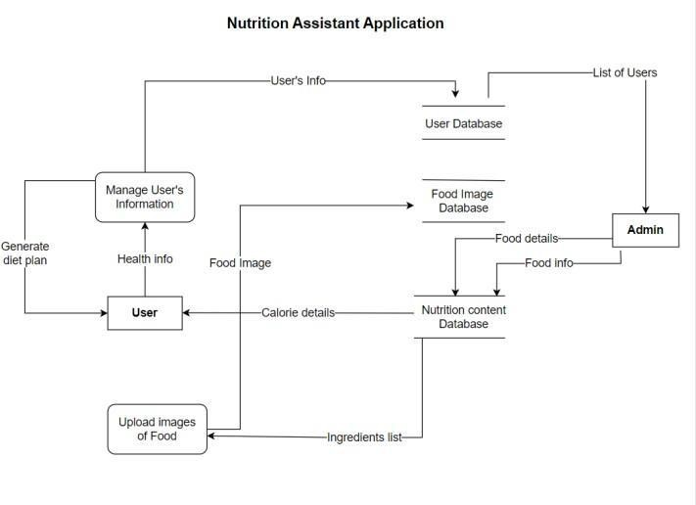

* + 1. SOLUTION REQUIRMENTS

**Project description:**

This project is aimed at developing a desktop-based application named

Nutrition Assistant Application for estimating food attributes such as ingredients and nutritional value by classifying the input images of food. The Nutrition Assistant Application refers to the system and processes to help the user to analyze the intake of food with the involvement of a Technology system. This system can be used to store the details of the user’s health, calculating the BMI, Classifying the food image to know the nutritional value, update the status of their health condition based on the information provided, and generate health reports weekly or monthly based. This project is categorizing the individual health condition of the user. The Nutrition Assistant Application is important to control their daily calorie intake by eating healthier foods, which is the most basic method to avoid obesity. Without proper diet control, and this is reflective of the risks to people’s health. A good Nutrition Assistant Application will alert the users when it is time to avoid. This project aims at building a web App that automatically estimates food attributes such as ingredients and nutritional value by classifying the input image of food.

**Scope**:

**Maintains good health**: The application can help in guiding them on how to remain healthy

and how to take good nutrition. The application will help them without personally going to the doctor. Promote better nutrition in the community by educating about better diet and nutrition.

**Functional limitation**: The user to be specific can’t access the web or admin module, whereas the administrator has all the rights to modify and manage the contents such as news, tips, etc

**Improve Usability**: In the part of user’s just the internet connection is enough in order to access the news, updates and other contents provided by the admin regarding their health condition.

**Health conscious:** This will provide convenience to persons/users who wants to learn about nutrition and other related health topics by just using the Nutrition Assistant Application

**Purpose**: The users continue to demand to know the nutritional value that is in their food. The users

learn about the effect of different foods on human health. Evidently, the ultimate aim of this application is to provide the ways in which one can lead a healthy life by maintaining his/her diet. The user can access the nutritional information by taking a photo of the food, uploading a photo from the gallery, or by entering manually. Nutrition is more than just obtaining nutrients and calories from food. It’s more than just eating the healthy stuff. It’s more than just following the most recent fad diet. Nutrition, the food we eat and the way we eat it, is an integral part of life. Nutrition is an experience. It evokes memories, helps us celebrate good times, and is there for us in times of grief. I believe the purpose of nutrition is to nourish the body and soul. The Nutrition Assistant Application helps the users to eat nutritional rich food which yield to lead a healthy life.

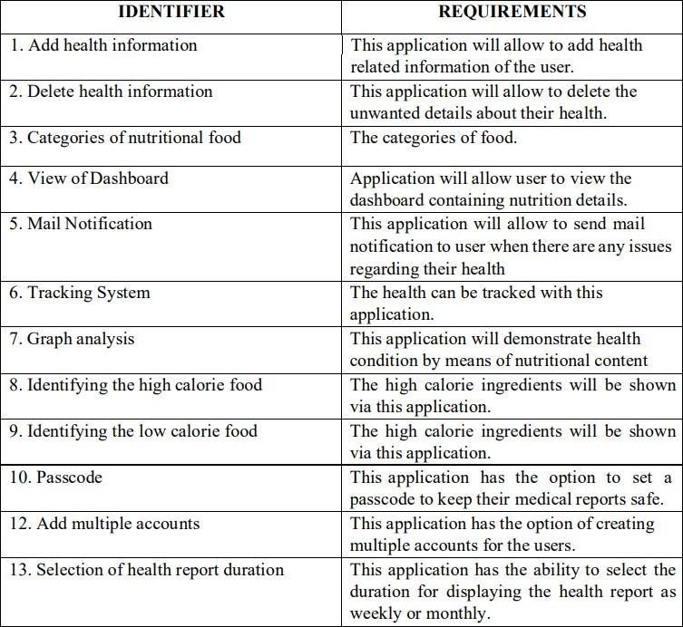

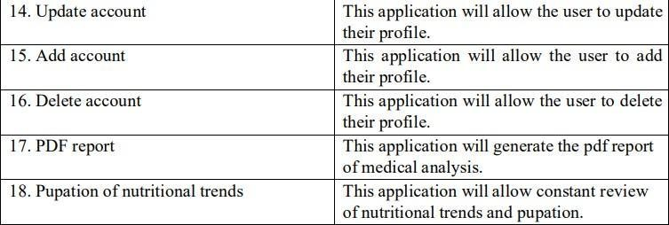

* + 1. TECHNOLOGY ARCHITECTURE

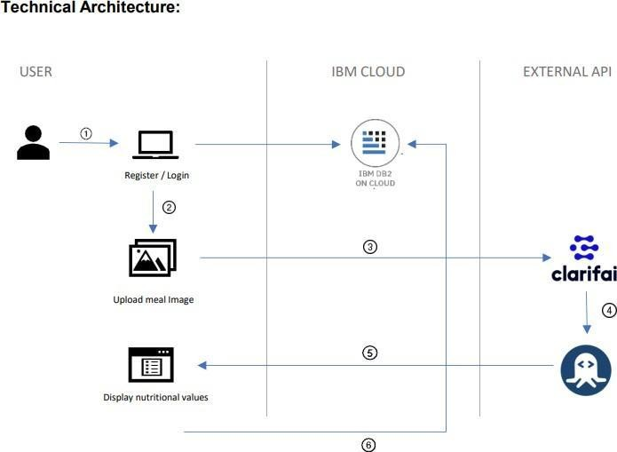

**Guidelines:**

1. To use the app the user must register / login.
2. After successful registration/login, the user can upload the meal image.
3. Using Clarifai AI- Driven API the name of the meal will be identified.
4. The identified name will be sent to Nutrition API using Flask.
5. Using Nutrition API, the nutritional value of the meal will be obtained and displayed in the UI using Flask.
6. The diet history will be added to the database to track their daily calorie intake.

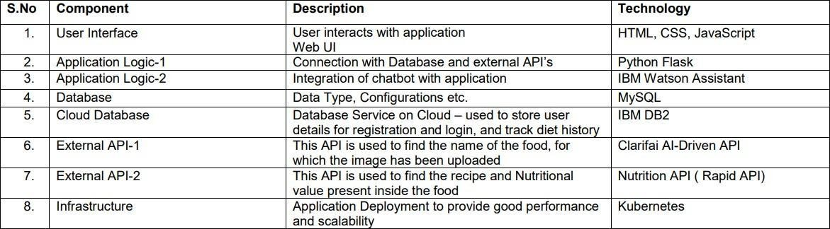Table 1: Components & Technologies:

Table 2: Application Characteristics:

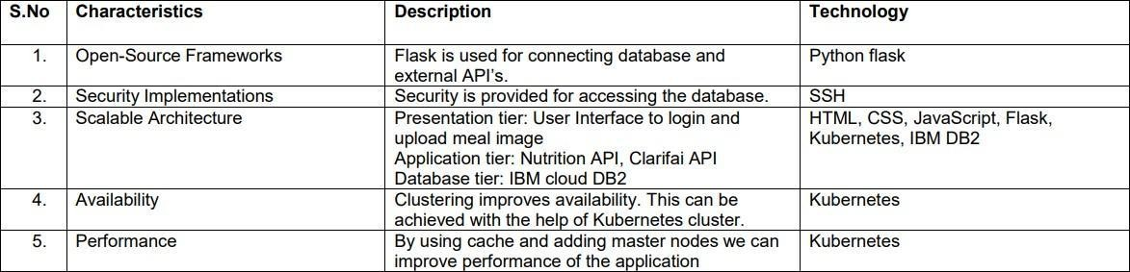

* + 1. USER STORIES
  + As a user, I can register for the application by entering my email, password, and Confirming my password
  + As a user, I will receive confirmation email once I have registered for the application
  + As a user, I can log into the application by entering email & password
  + As a user, I can fill the details.
  + As a user, I will search the food items.
  + As a user, I can scan the food an get the nutrition details and recipe for related scanned food.

1. PROJECT PLANNING AND SCHEDULING
   1. SPRINT PLANNING & ESTIMATION

|  |  |  |  |  |  |  |
| --- | --- | --- | --- | --- | --- | --- |
| **Sprint** | **Functional** | **Use** | **User Story / Task** | **Story** | **Priority** | **Team Members** |
|  | **Requirement** | **r** |  | **Points** |  |  |
|  | **(Epic)** | **Stor** |  |  |  |  |
|  |  | **y** |  |  |  |  |
|  |  | **Nu** |  |  |  |  |

|  |  |  |  |  |  |  |
| --- | --- | --- | --- | --- | --- | --- |
|  |  | **mbe**  **r** |  |  |  |  |
| Sprint-1 | User Panel | USN-1 | The user will login into the website, enter his height & | 20 | High | RIDHANYA P |
|  |  |  | weight and also upload the food he wants to eat on the website. |  |  | RISHIYUGAN S RAKESH R  RICHARD JACOB |
| Sprint-2 | Admin Panel | USN-2 | The admin uses the Clarifai | 20 | High | RIDHANYA P  RISHIYUGAN S RAKESH R RICHARD JACOB |
|  |  |  | API to identify the food and |  |  |
|  |  |  | Nutrition API to find the |  |  |
|  |  |  | amount of nutrition present |  |  |
|  |  |  | in that food. |  |  |
| Sprint-3 | Chat Bot | USN-3 | The user can also | 20 | High | RIDHANYA P  RISHIYUGAN S RAKESH R RICHARD JACOB |
|  |  |  | directly talk to the |  |  |
|  |  |  | webpage and ask |  |  |
|  |  |  | questions using the |  |  |
|  |  |  | chatbot |  |  |
| Sprint-4 | Final Delivery | USN-4 | Integrate the application to | 20 | High | RIDHANYA |
|  |  |  | Cloud using Docker and |  |  | P |
|  |  |  | Kubernetes. Submit the |  |  | RISHIYUGAN S |
|  |  |  | report of the final |  |  | RAKESH R |
|  |  |  | application. |  |  | RICHARD JACOB |

* 1. Sprint Delivery Schedule

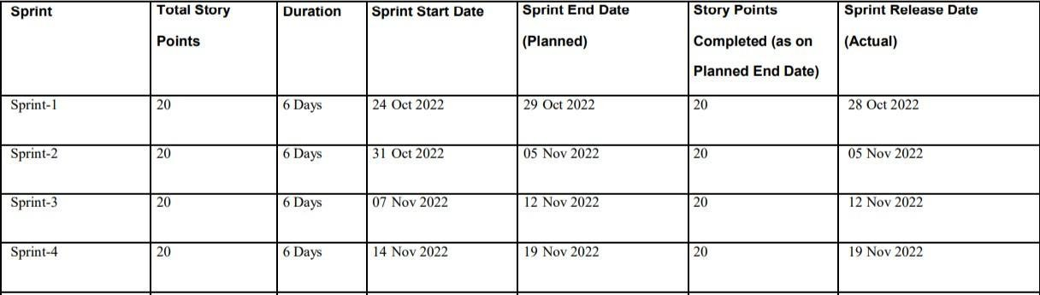

1. CODING & SOLUTIONING
   1. FEATURE 1

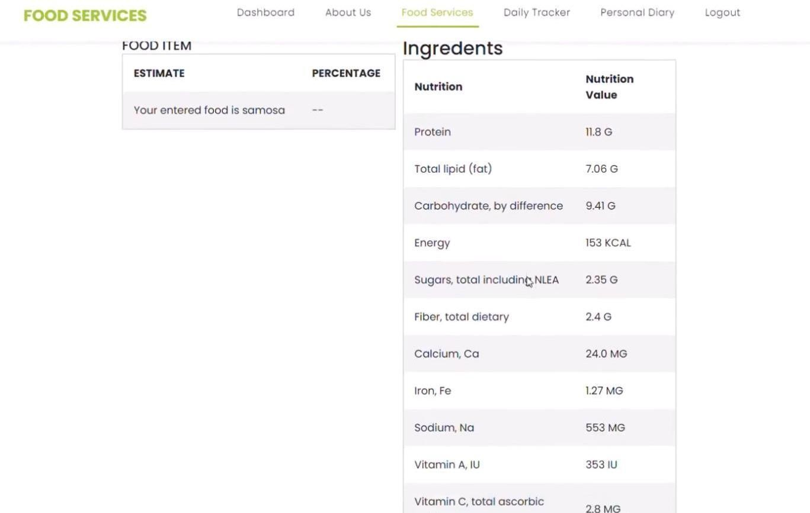The user can upload any food image Nutrients present in the uploaded image will be displayed

* 1. FEATURE 2

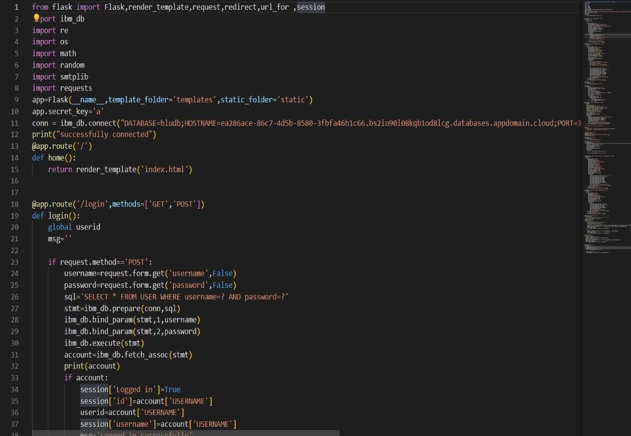

1. TESTING
   1. TEST CASES
      1. Our code was tested on various food to check whether it gives the correct output
      2. To satisfy the customer’s expectations we tested it fully.
   2. USER ACCEPTANCE TESTING

Our project was tested by an end user to verify that it’s working correctly.

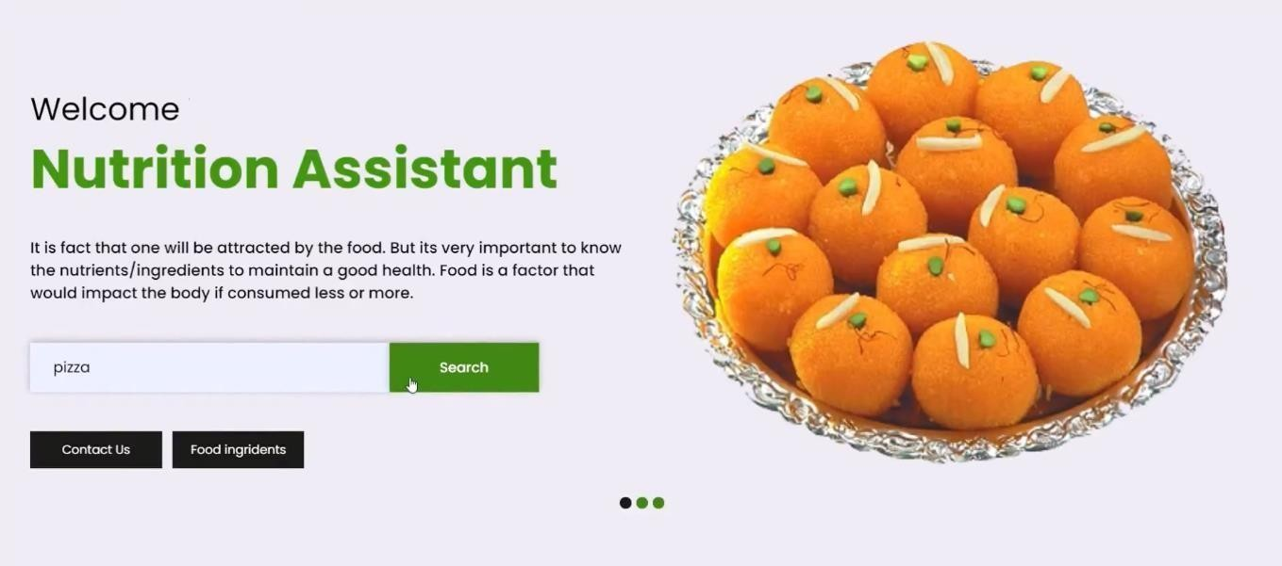

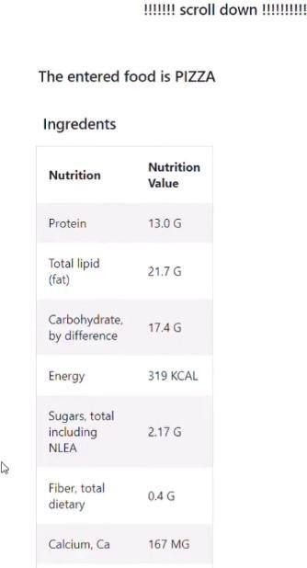

1. RESULT

10.1 PERFORMANCE METRICS

The proposed procedure was implemented and tested set of images. The training database consists of various images of food items. Once a food is recognized the equivalent **Nutrition** in shown on the screen.

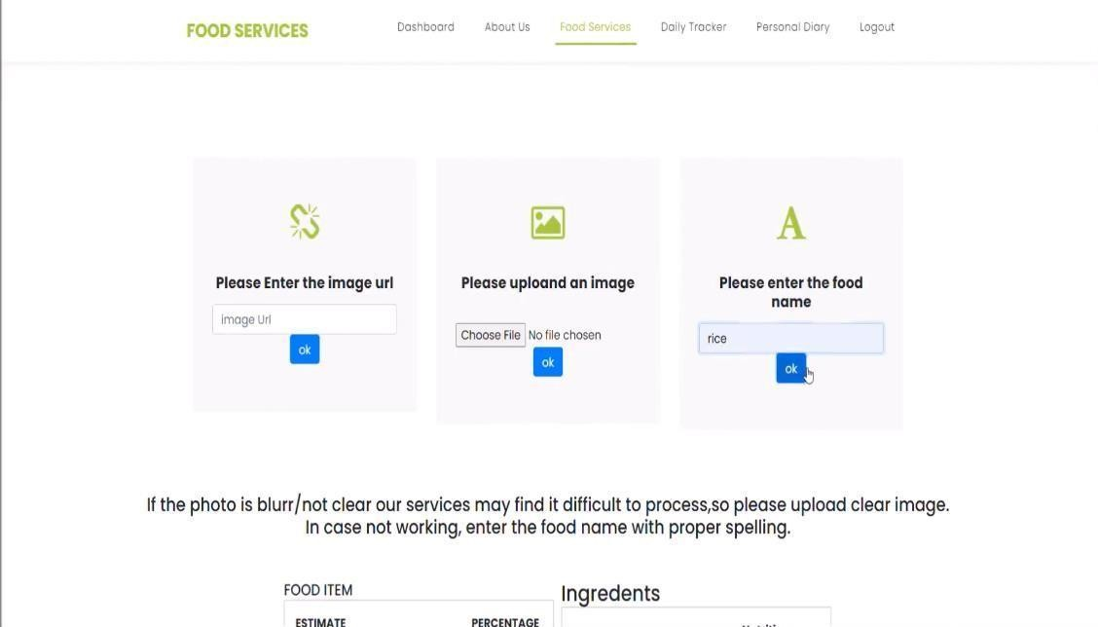

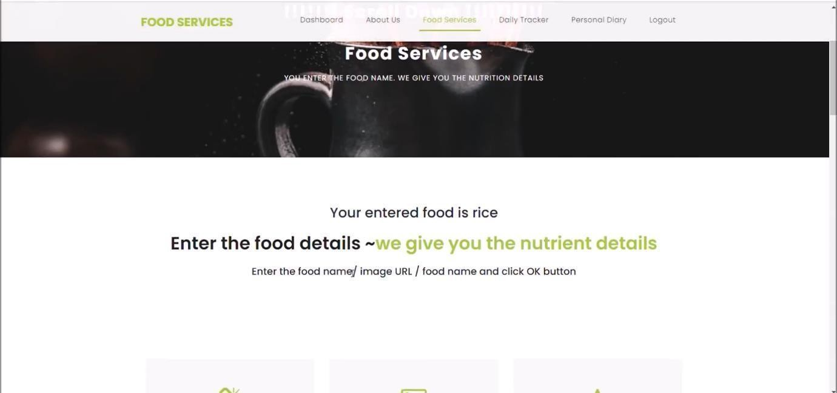

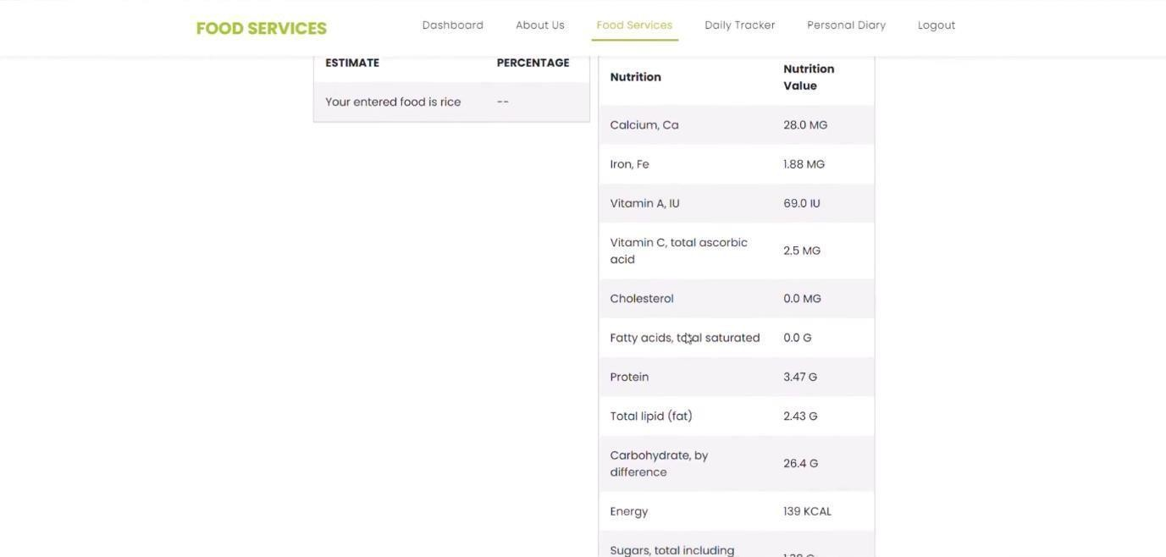

1. ADVANTAGES:

* It provides a maintained strategy of healthy eating habits.
* It delivers information on the nutritional value of foods and how balanced and healthy eating habits are important for us.
* It limits the amount of unnecessary food such as fat that people consume a lot.

1. CONCLUSION

In conclusion, many people have become aware of their health. Moreover, they are also informed how to live a healthy lifestyle. Most of the research related to these themes aims to identify changes in healthy lifestyle behavior with web applications that are considered effective in dietary self-monitoring.

1. DESCRIPTION:

Nutrition assistants help dieticians with providing proper nutrition at healthcare facilities. They determine patients' nutritional needs, assess risk factors, and plan meals and menus. They also ensure proper sterilization of plates and utensils.

1. APPENDIX

**Source Code:**

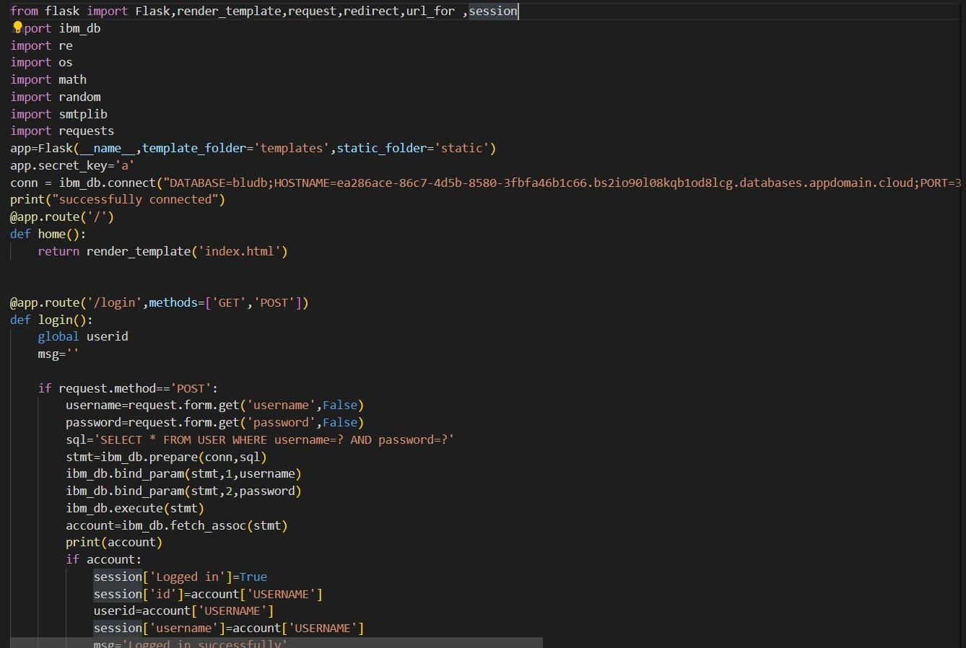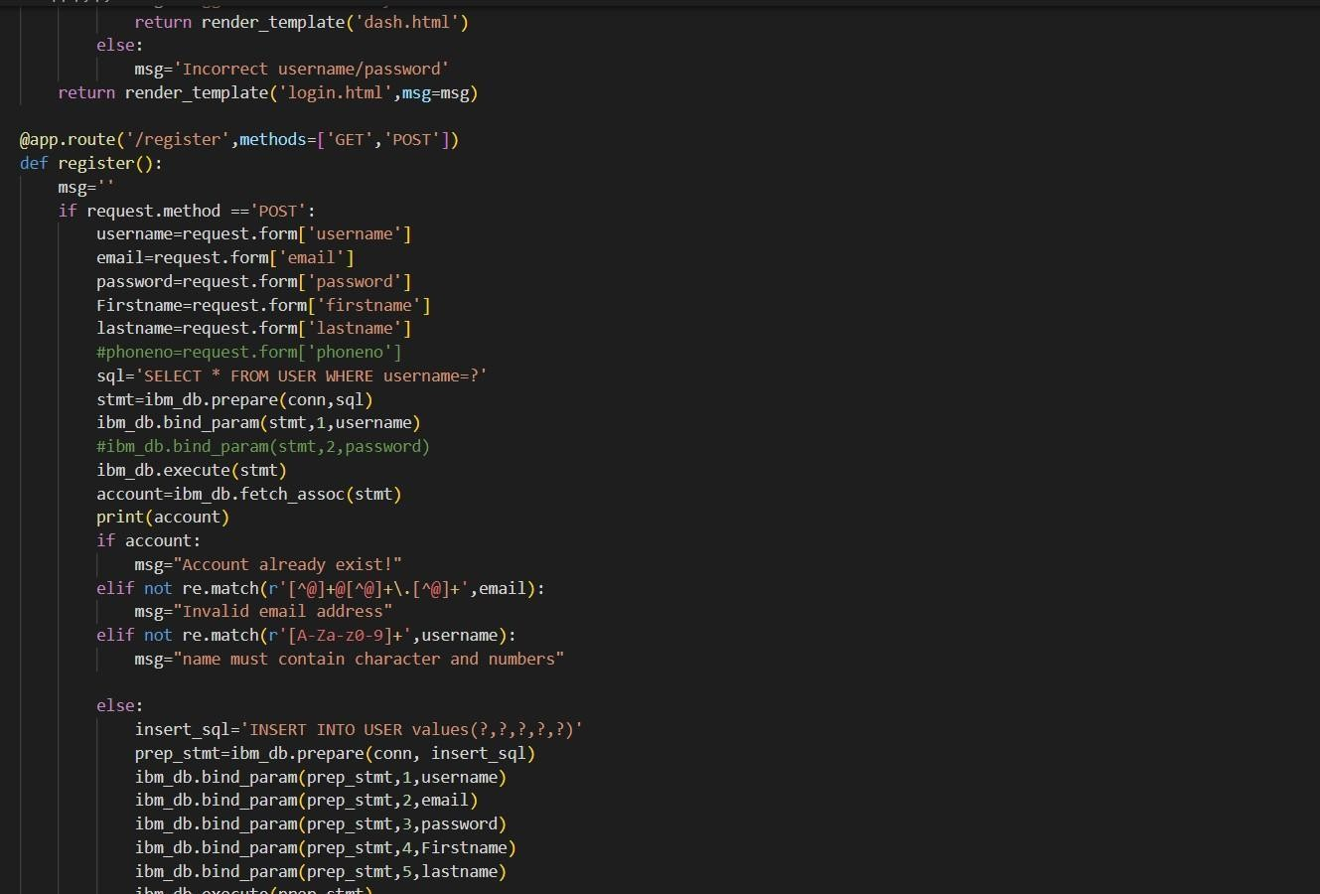

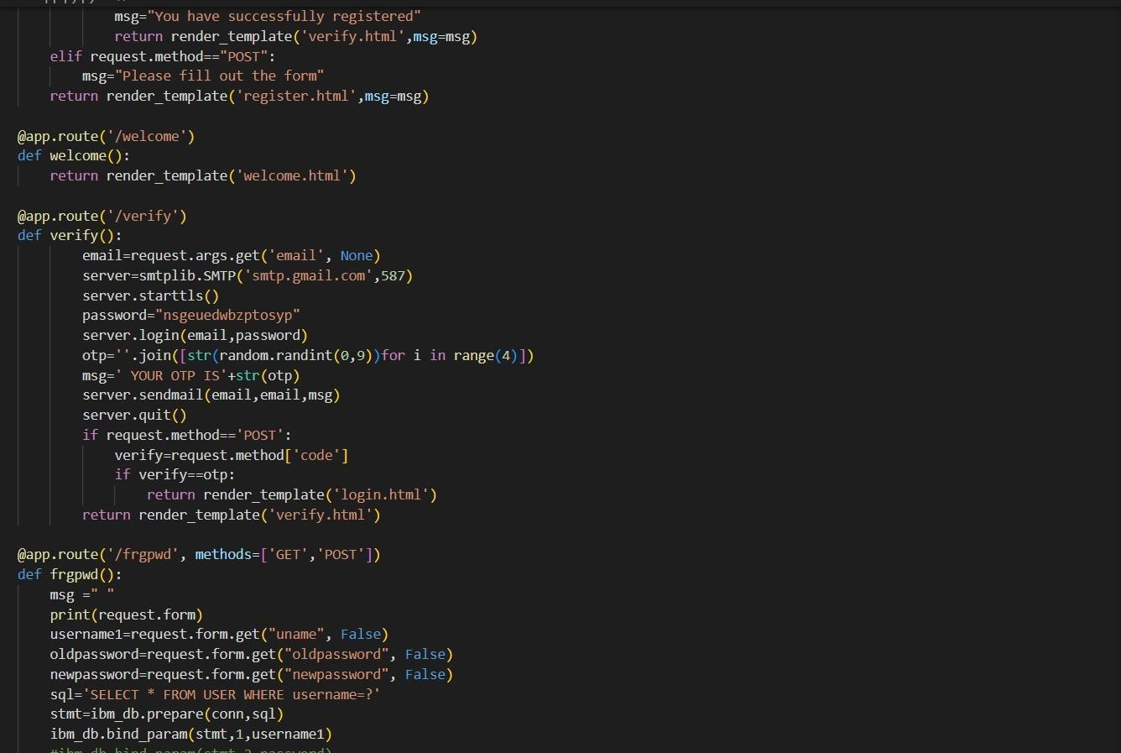

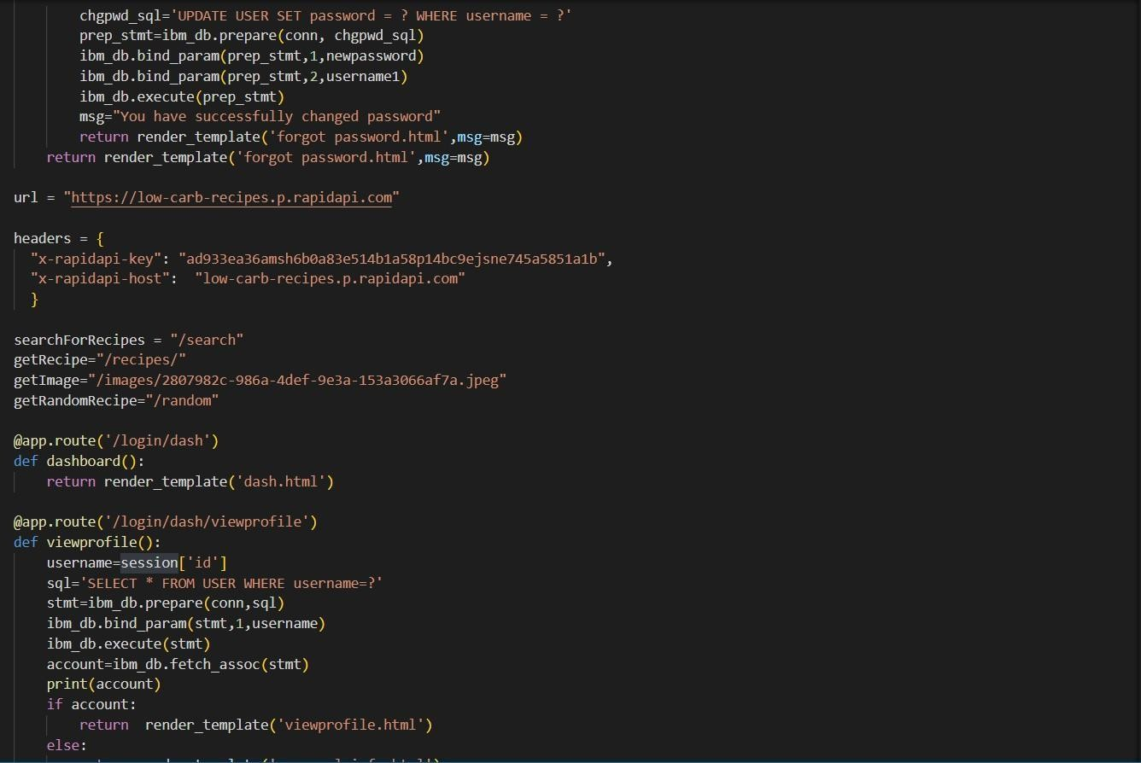

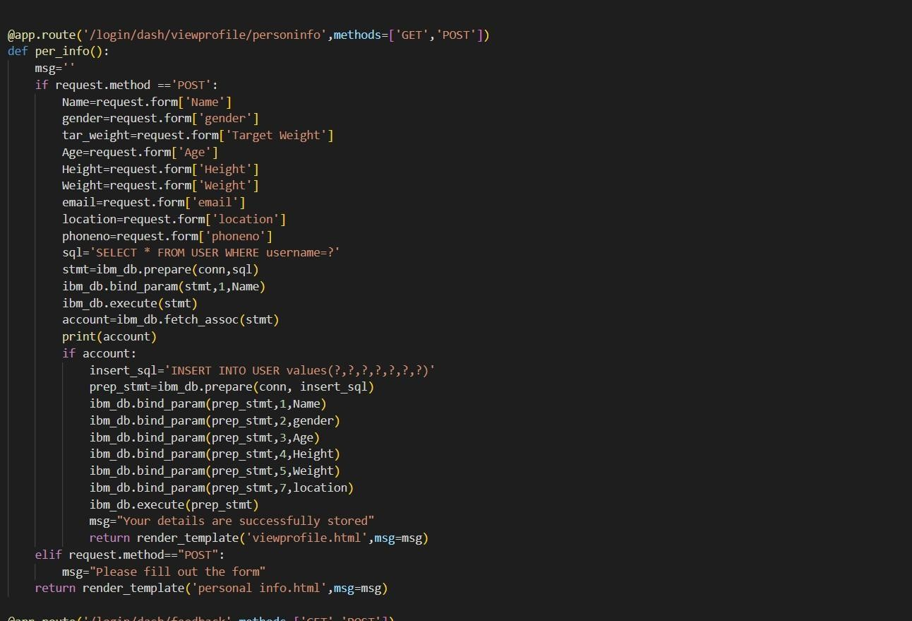

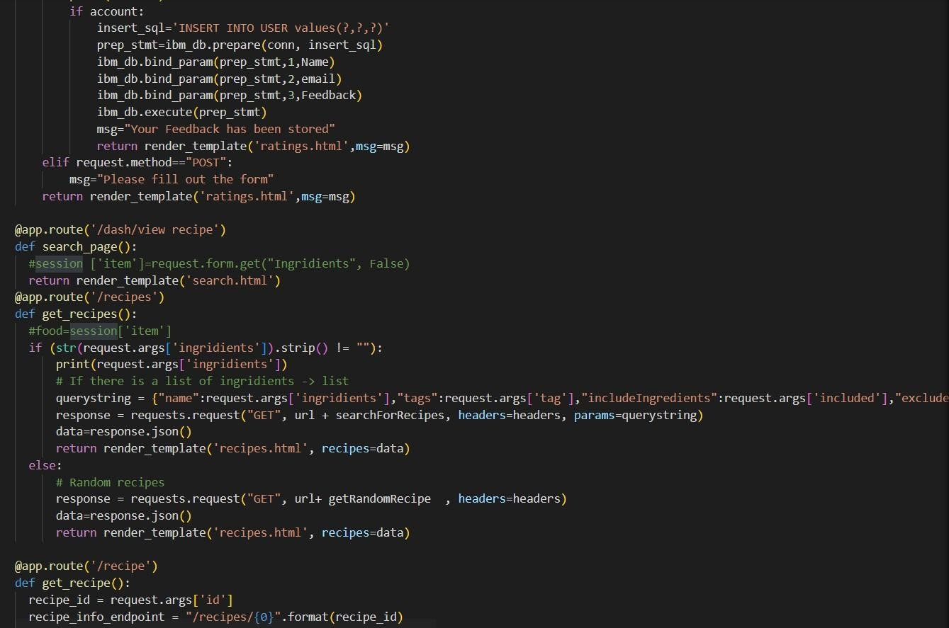

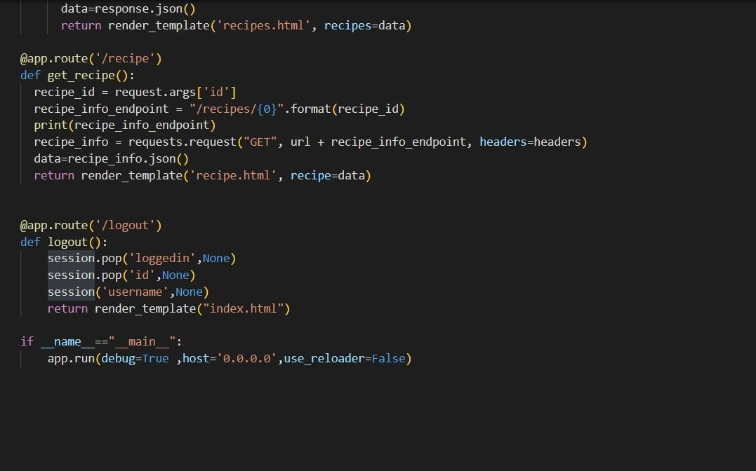

**GitHub:**

**https://github.com/IBM-EPBL/IBM-Project-14927-1659592364**